ACSL
American Computer Science League
2012 - 2013

Contest #3

Senior Division Solutions

- Boolean Algebra
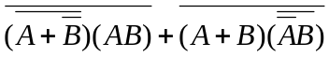 = 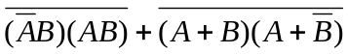
=
= 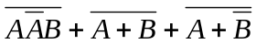=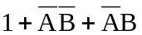= 1

1. 1

2. 8
- Boolean Algebra

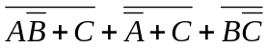=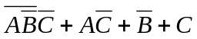
=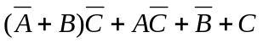=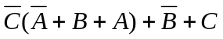
= 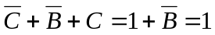

3. A & B and
A & E
- Graph Theory
0 | 0 | 1 | 0 | 0 | 4 |  | 4 | 0 | 2 | 3 | 0
1 | 0 | 1 | 1 | 0 |  |  | 6 | 3 | 9 | 5 | 3
1 | 0 | 0 | 1 | 0 |  | = | 2 | 3 | 7 | 2 | 3
0 | 1 | 1 | 0 | 1 |  |  | 9 | 2 | 8 | 7 | 2
1 | 0 | 1 | 0 | 0 |  |  | 4 | 1 | 4 | 3 | 1

Therefore no path of length 4 exists between A & B and A & E

4. 5
- Graph Theory
There are 5 cycles from C: CC, CABC, CAEC, CBC, and CEC.

- Bit-String Flicking
Let X = abcde
LHS = (LCIRC-2 01011) OR X
= 01101 OR abcde
= a11d1
RHS = RSHIFT-1 11011 = 01101
a11d1 = 01101→ a = 0, b = *, c = *, d = 0, e = * → 0**0*

5. 0**0*

